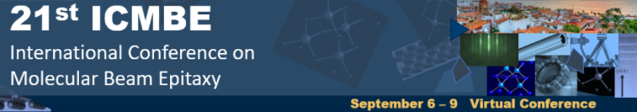
Virtual Conference - Puerto Vallarta, Mexico – September 6-9, 2021
Authors List
Abstract code: ________ (obtained by email during the first step of abstract submission)
Please fill in the data in the same order as names appear in the abstract.
Do not forget to indicate one corresponding (CA) author and one presenting (PA) author.
 | Title | Name | Last Name | Email | Organization | Department | Zip Code | City | Country | CA | PA
1
2
3
4
5
6
7
8
9
10
11
12

Please add rows if necessary. Include this file in the email together with the extended abstract.
Rename this file as 21ICMBE_AuthorsList_AbsCODE.docx by replacing
AbsCODE with the abstract code number you received by email during
the first step of the submission process.

